NEW
Corvette Rochester Carburetor #17053295 from a 78 Corvette/L48 with AT/AC recently has been professionally refurbished and ready to go. Doesn't need rebuild and can be installed/modified for several GM applications for Chevy/GM 350 engines.
$500.00 FIRM
Text me @ 302 423 2326 Michael Kane

WTB a#17058206
Quadra Jet Carb for a 78-79 L48 A/T A/C application

Contact Michael Kane
302-423-2326 TEXT ONLY

NEW, only 600 miles on tires, set of C7 tires & wheels.
Front: P245/35 ZR 19
Rear: P285/30 ZR 20
These are Michelin Summer Tire Run Flats.
Excellent price, only $1250.

Also for sale, a C7 Wire Cover kit, $100.

Items are located in DE. Call Orville Mills, 302-228-3855. FSCC Member
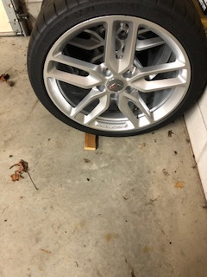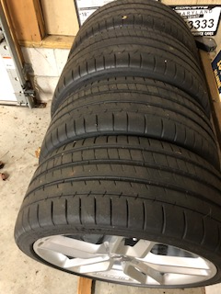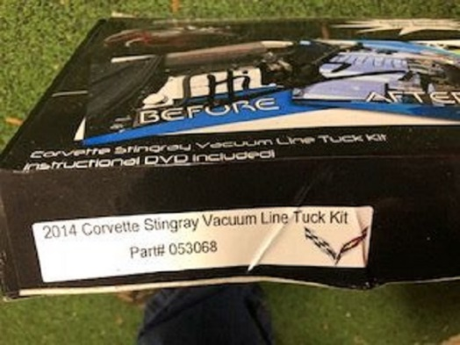

1960 Corvette, 350, 4-speed, 355 posi, power windows, new interior and door panels, complete power train rebuild (1200 miles). Both tops. $80,000.
Richard Webb
Milford, DE
302-236-1795
rickwebb001@gmail.com
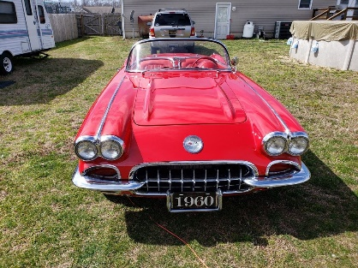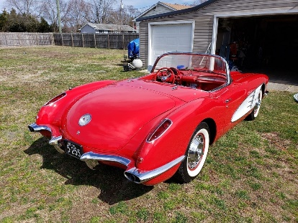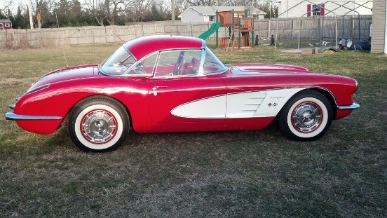

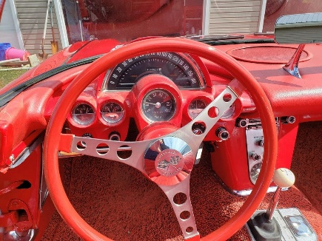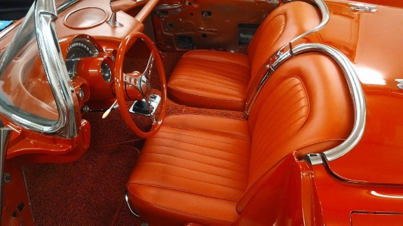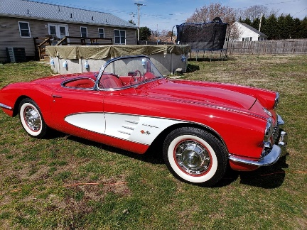

2009 Convertible .. I have it at Solloway’s in Smyrna. Its a Beautiful car and 3LT with Navigation and Power Convertible top plus extras. 56, 000 miles in MINT condition. Automatic BRAND NEW TIRES. $25,300. The details can be found at Solloway's in Smyrna. Thank you, Dennis Mansour
FSCC 